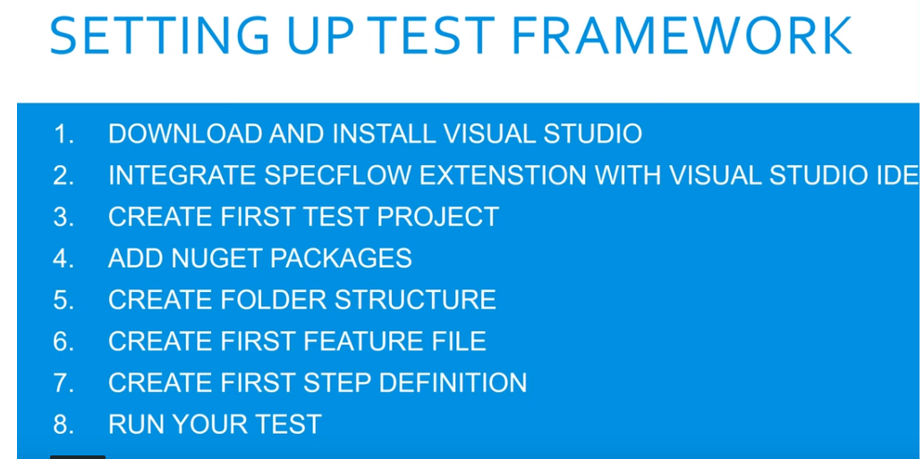

To download

visual studio IDE – <https://visualstudio.microsoft.com> > Download for Windows > Community 2017 (free) > Continue > Continue (will download & install > >

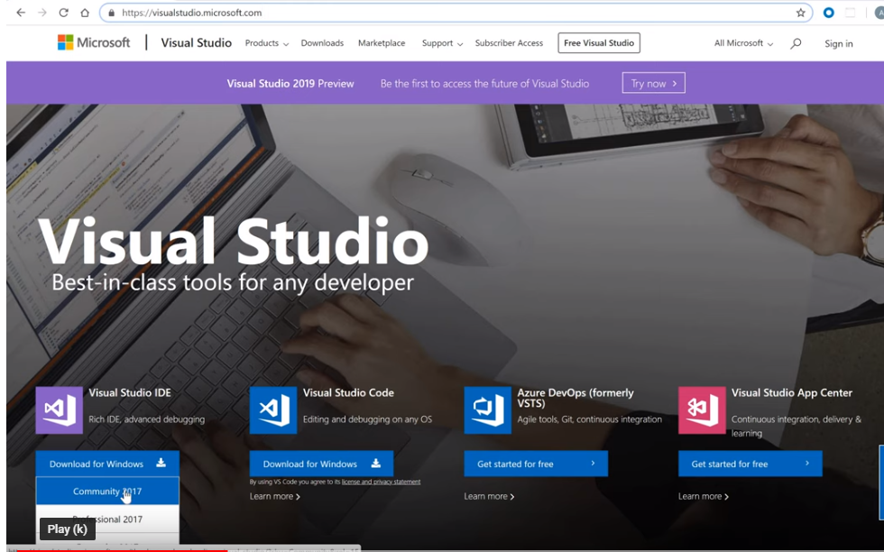

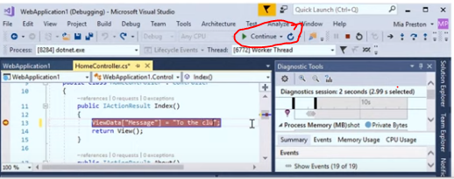

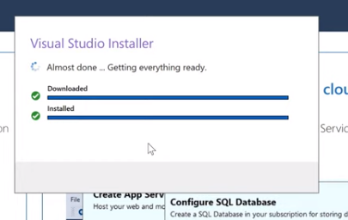

How do you know its done correctly? What do you see?

2/ Integrate specflow extension with visual studio IDE

Open visual studio > click Tools >extension > update > Online (internet access) > enter specflow in search text box > Must see download buton (unless already extended) > click download > Finish (message re change schedule displayed at buttom of window) > close VS IDE (close & X) & reopen > window pop up (with message to modify VS > cliuck Modify (only do once & this not adding nuget pagage) > click close > re open VS > check exten extended (click Tool >extension>update>installed) > you also enter specflow in search & specflow displayed with agreen tick which means already installed > close.

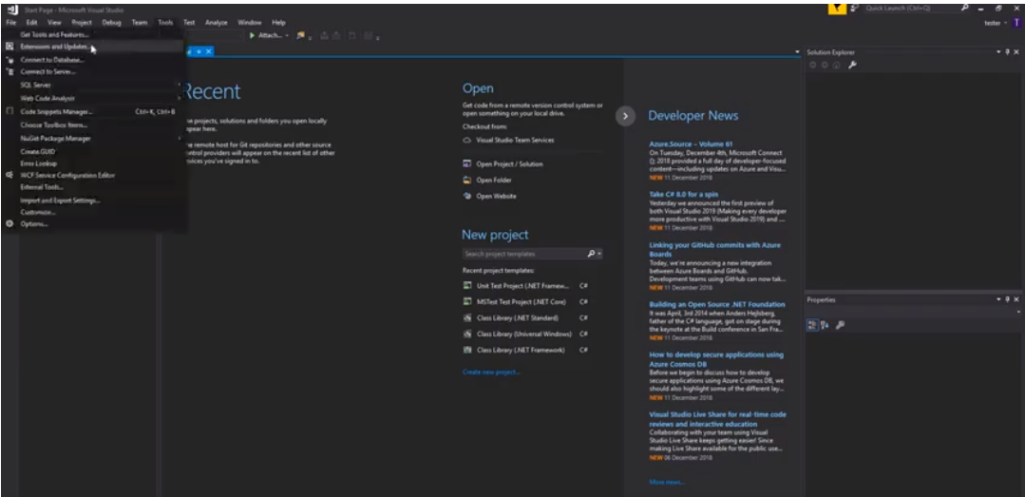

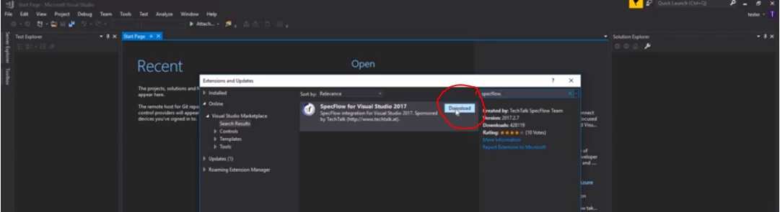



Specflopw extended

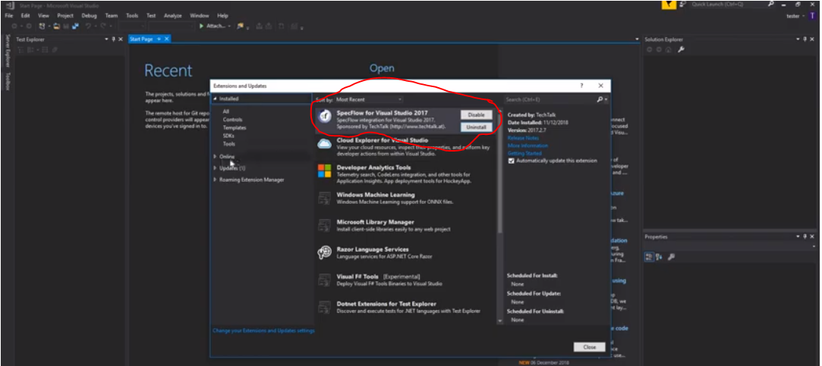

specflow and

selenium

5.3 – Creating first test project – 7 minutes

Open VS > File > New > Project > Click Test or check its auto selected > Unit Test Project (.Net Framework) > Change project name > Browse > click New folder (to create another folder to put the project into) > Name the folder > select folder just created > Tick “ create directory for solution box, “Add to source control” blank > OK solution created > In Solution explorer window (last window) – will disdplay your training folders, delete the “Unit Test.cs” folder > Test explorer section will display your test > The middle window is where you write your code > refresh your code by rebuilding your solution (right click “Solution training (1 Project) > Build solution >

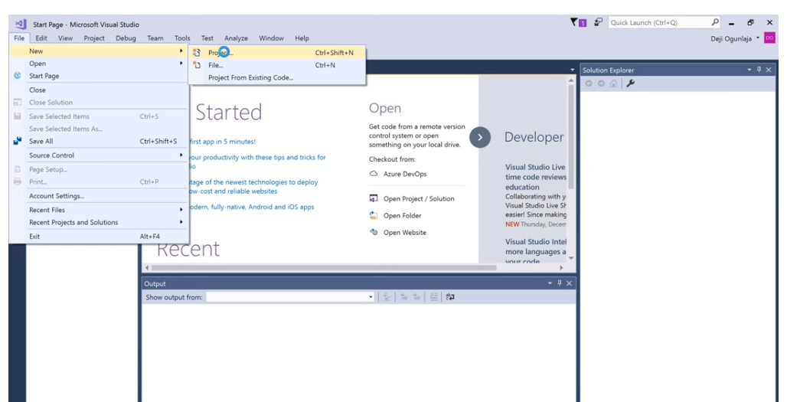

Solution created

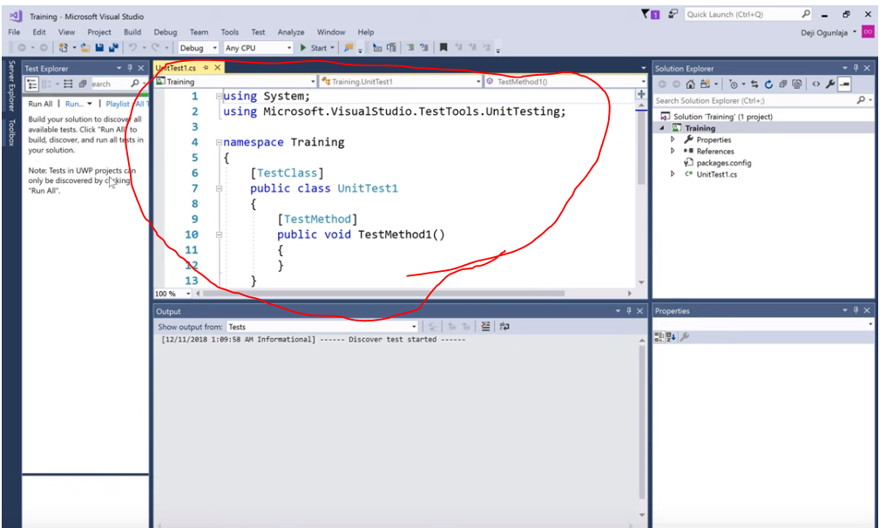

Build successful message

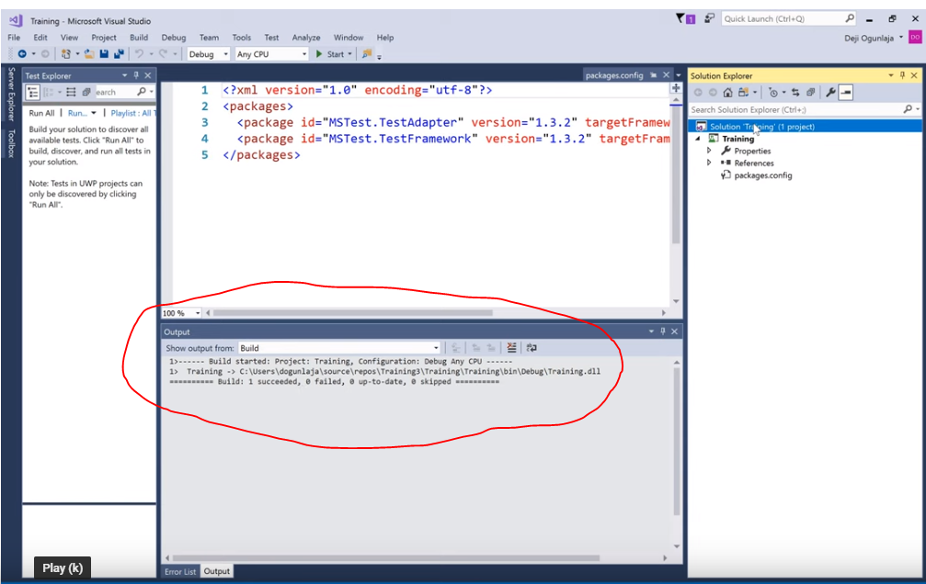

Class 5.4 Add Nuget Packages 14 miunutes

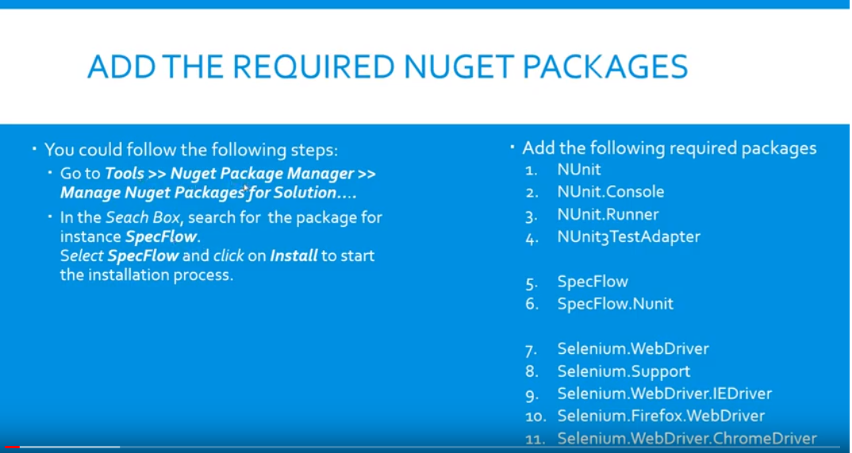

C:\Users\mbalogun\source\repos

After bringing up Manage nuget Packages for Solution > check you two nuget packages installed by default.

As we install you will see them in your Solution Explorer Window

Check Packages.config file(last file in Solution Explorer Window) > should have the 2 default pakages.

2 ways to add nuget packages 1/ tools>nuget package managers>manage nuget package for solution. 2/ right click “Solution training (1 Project)> manage nuget package for solution > Will take you to where you can browse for your solution > Click Browse > search for required nuget packages > highlight it > tick the project you want to install it too> install > Click Ok to preview changes window > lower green icon shows it installed > confirmation message at bottom of screen [REPEAT PROCESS FOR ALL THE PACKAGES)

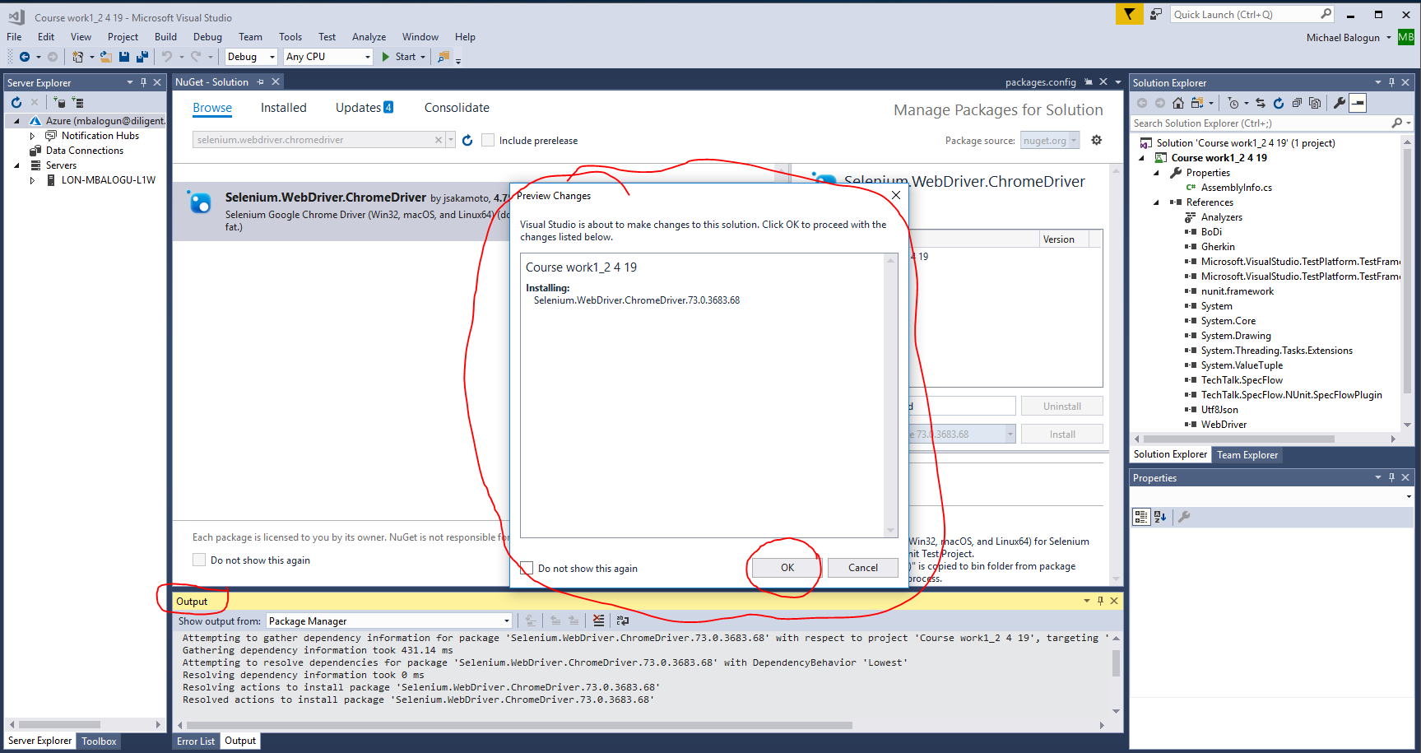

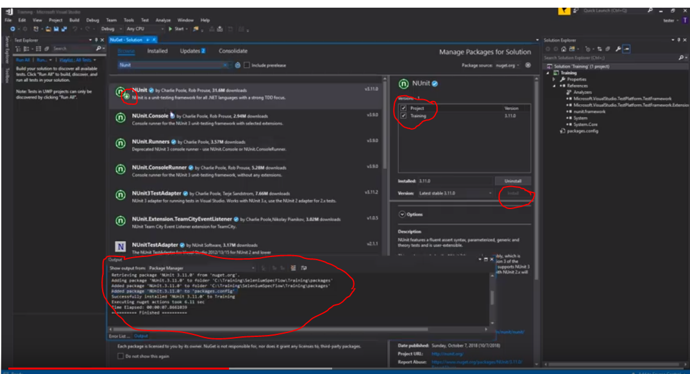

1 NUnit 2/ NUnit.Console 3/ NUnit.Runners 4/ NUnit3TestAdapter

5/ SpecFlow 6/ SpecFlow.NUnit

7/ Selenium.WebDreiver 8/ Selenium.Support 9/ Selenium.WebDriver.IEDriver 10/ Selenium.Firefox.WebDriver 11 Selenium.WebDriver.ChromeDriver

Check packages .com for all package

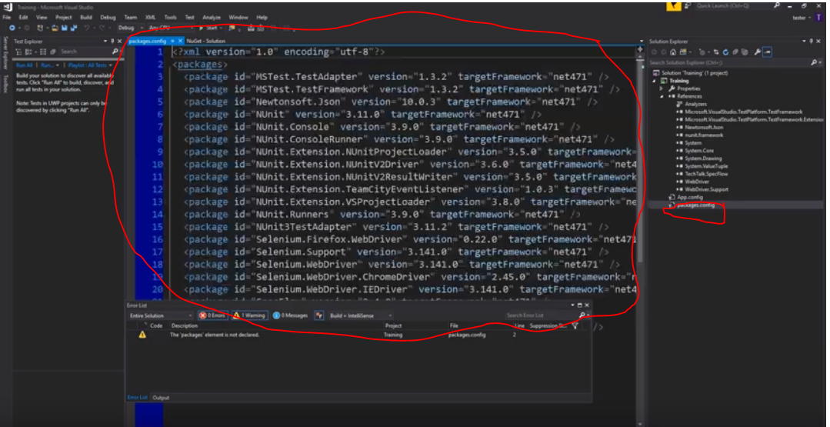

Check appconfig for specflow and only 1 UnitTestProvider

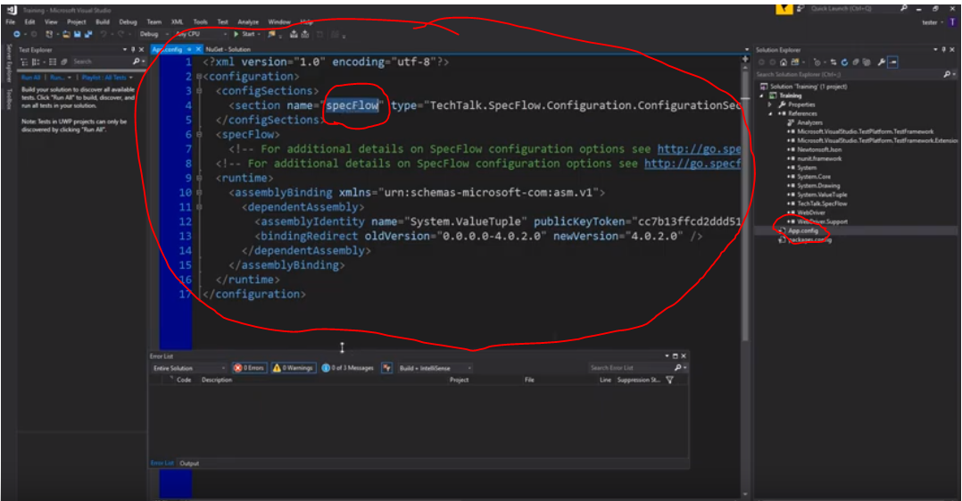

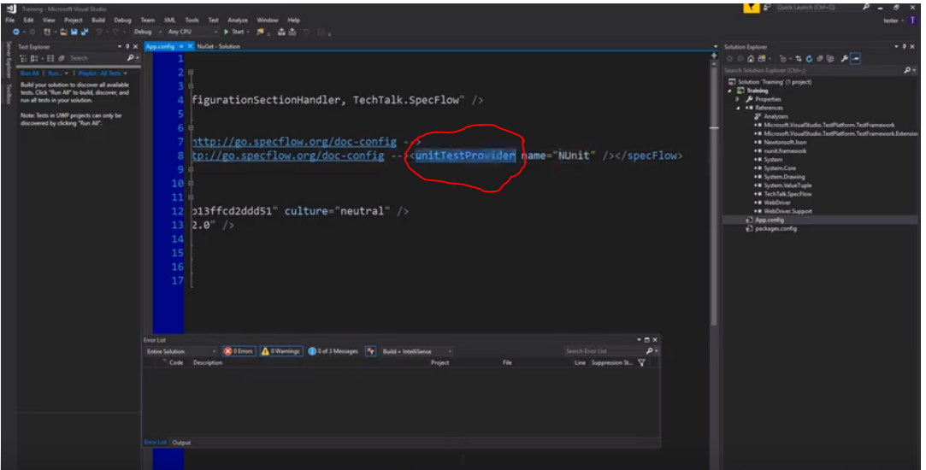

Class 5.5 Create folder structure 4minutes

Solution explorer > right click Training (your folder name) > Add > New Folder > Name folder “Features” (REPEAT Page Objects, Step Definitions & Utilities)

Features – will contain specflow feature files

Page Objects - classes for each of the page you want to test.

Step Definitions – steps created from your feature files

Utilities - helper classes & any file not for the first 3 files.

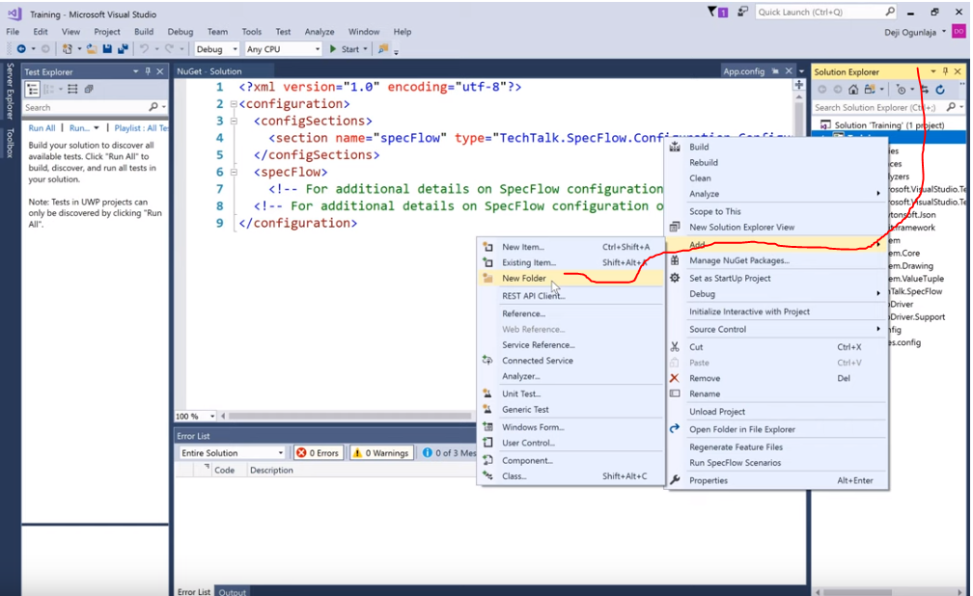

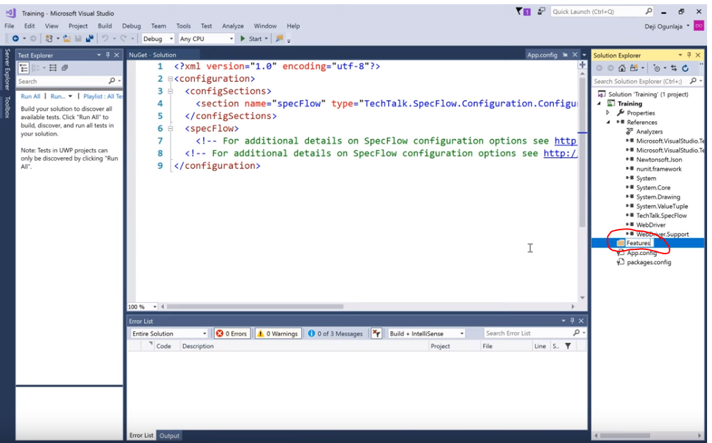

Class 5.6 create first feature file 11 minutes

